

**Unit**

**-**

**1**

**Fundamentals of AI and Machine**

**Learning**

Contents

1.1 Concept of Machine Learning ............................................................................................................................................ 1

1.1.1 Understanding Machine Learning: ...................................................................................................................................... 1

1.1.2 Benefits of Machine Learning .............................................................................................................................................. 1

1.1.3 Difference between AI, ML, and Deep Learning .................................................................................................................. 2

1.2 Machine learning Life Cycle .............................................................................................................................................. 5

1.2.1 Stages of ML Life Cycle ........................................................................................................................................................ 5

1.2.2 Problem Definition to Model Monitoring ............................................................................................................................ 8

1.3 Types of Exploratory Data Analysis (EDA) ......................................................................................................................... 8

1.3.1 Types of Exploratory Data Analysis (EDA) ............................................................................................................................. 9

1.3.2 Univariate Analysis? ........................................................................................................................................................... 10

1.3.3 Bivariate Analysis ............................................................................................................................................................... 12

1.3.4 Multivariate Analysis ........................................................................................................................................................... 14

1.3.5 Handling Missing Data ....................................................................................................................................................... 15

1.3.6 Detecting and Handling Outliers ........................................................................................................................................ 17

1.4: Understanding the Data ................................................................................................................................................. 20

1.4.1 Quantitative Data (Numerical Data) .................................................................................................................................. 20

1.4.1.1 Discrete Data .................................................................................................................................................................. 21

1.4.1.2 Continuous Data ............................................................................................................................................................. 22

1.4.2 Qualitative Data (Categorical Data) ................................................................................................................................... 22

 1.4.2.1.1 Nominal Data ........................................................................................................................................................ 23

1.4.2.2 Ordinal Data .............................................................................................................................................................. 23

1.5 Spread of Data ................................................................................................................................................................. 24

1.5.1 Normal Distribution ........................................................................................................................................................... 25

1.5.2 Skewed Distribution ........................................................................................................................................................... 25

1.5.3 Skewness Simple Definition: .............................................................................................................................................. 26

1.5.4 Kurtosis .............................................................................................................................................................................. 27

# 1.1 Concept of Machine Learning

**1.1.1 Understanding Machine Learning:**

**What is Machine Learning?**

Machine Learning (ML) is a field in computer science where computers learn from data and make decisions or predictions — without being directly programmed for

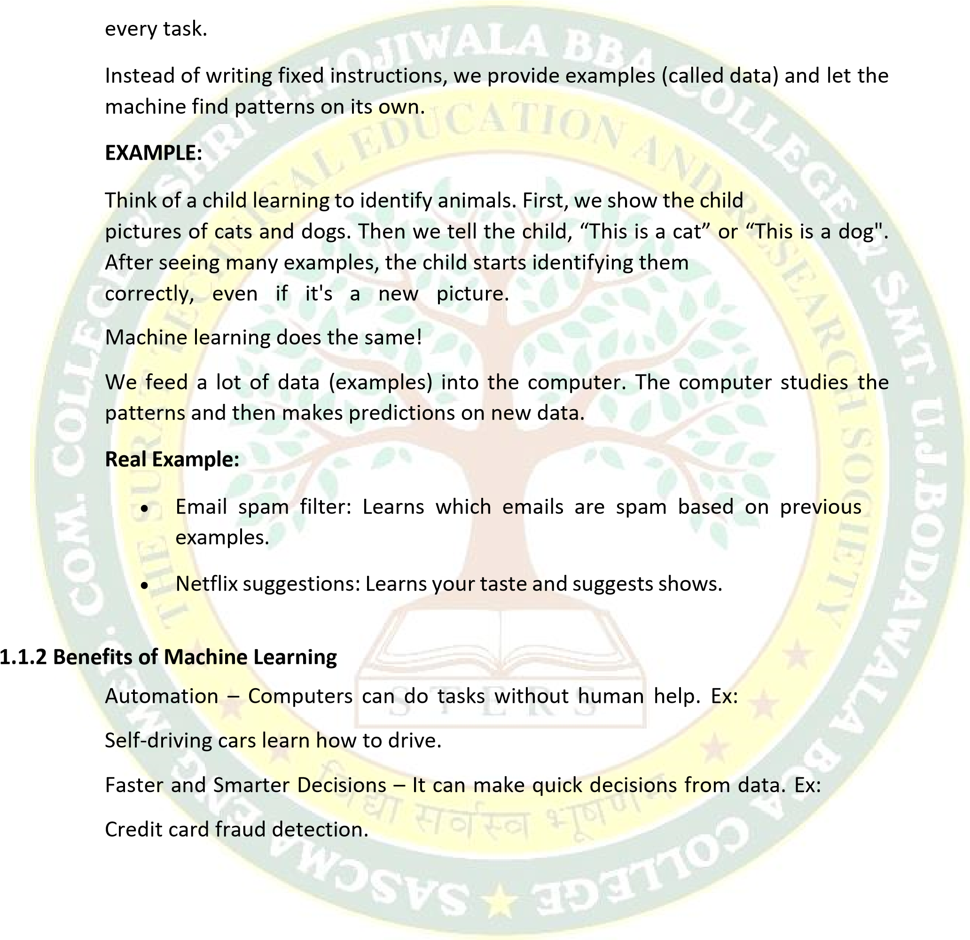Personalization – It gives results suited just for you.

Ex: YouTube recommends videos based on your interests.

Improves Over Time – The more data it gets, the better it becomes. Ex:

Voice assistants like Alexa learn your voice over time.

Solves Complex Problems – Like medical diagnosis or language translation.

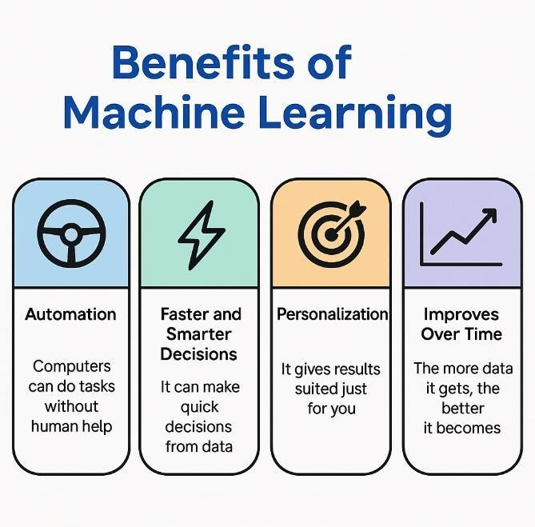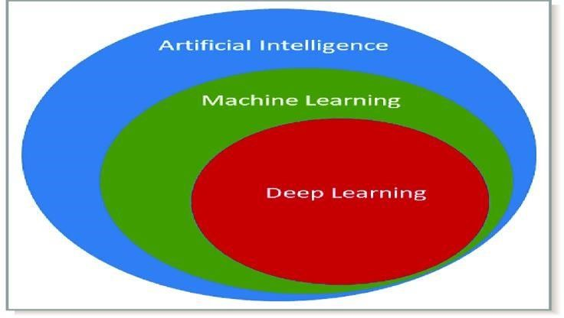

**1.1.3**

**Difference between AI, ML, and Deep Learning**

**What**

**is**

**Artificial**

**Intelligence**

**(**

**AI)?**

* AI is the goal — It’s the final product: making a machine or system think and act smart like a human.
* AI is about giving intelligence to computers so they can solve problems, understand, learn, and respond — just like humans.
* AI includes everything from if-else rules, machine learning, robotics, language understanding, and more.

**Analogy:**

Think of AI as a self-driving car — that’s the smart final product**.**

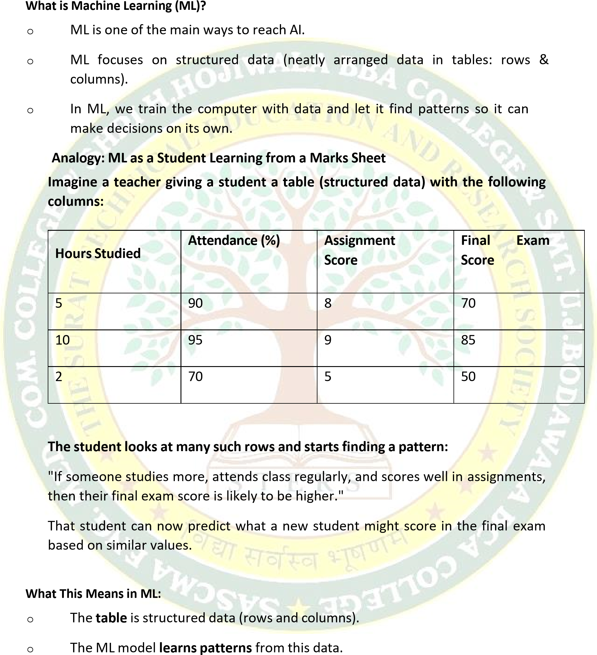

o Then it can **predict or decide** based on new input.

**What is Deep Learning (DL)?**

DL is a **special part of ML** that uses structures called **neural networks** — inspired by the human brain.

• **DL is used when the data is unstructured**, like: o Images o Videos o Audio

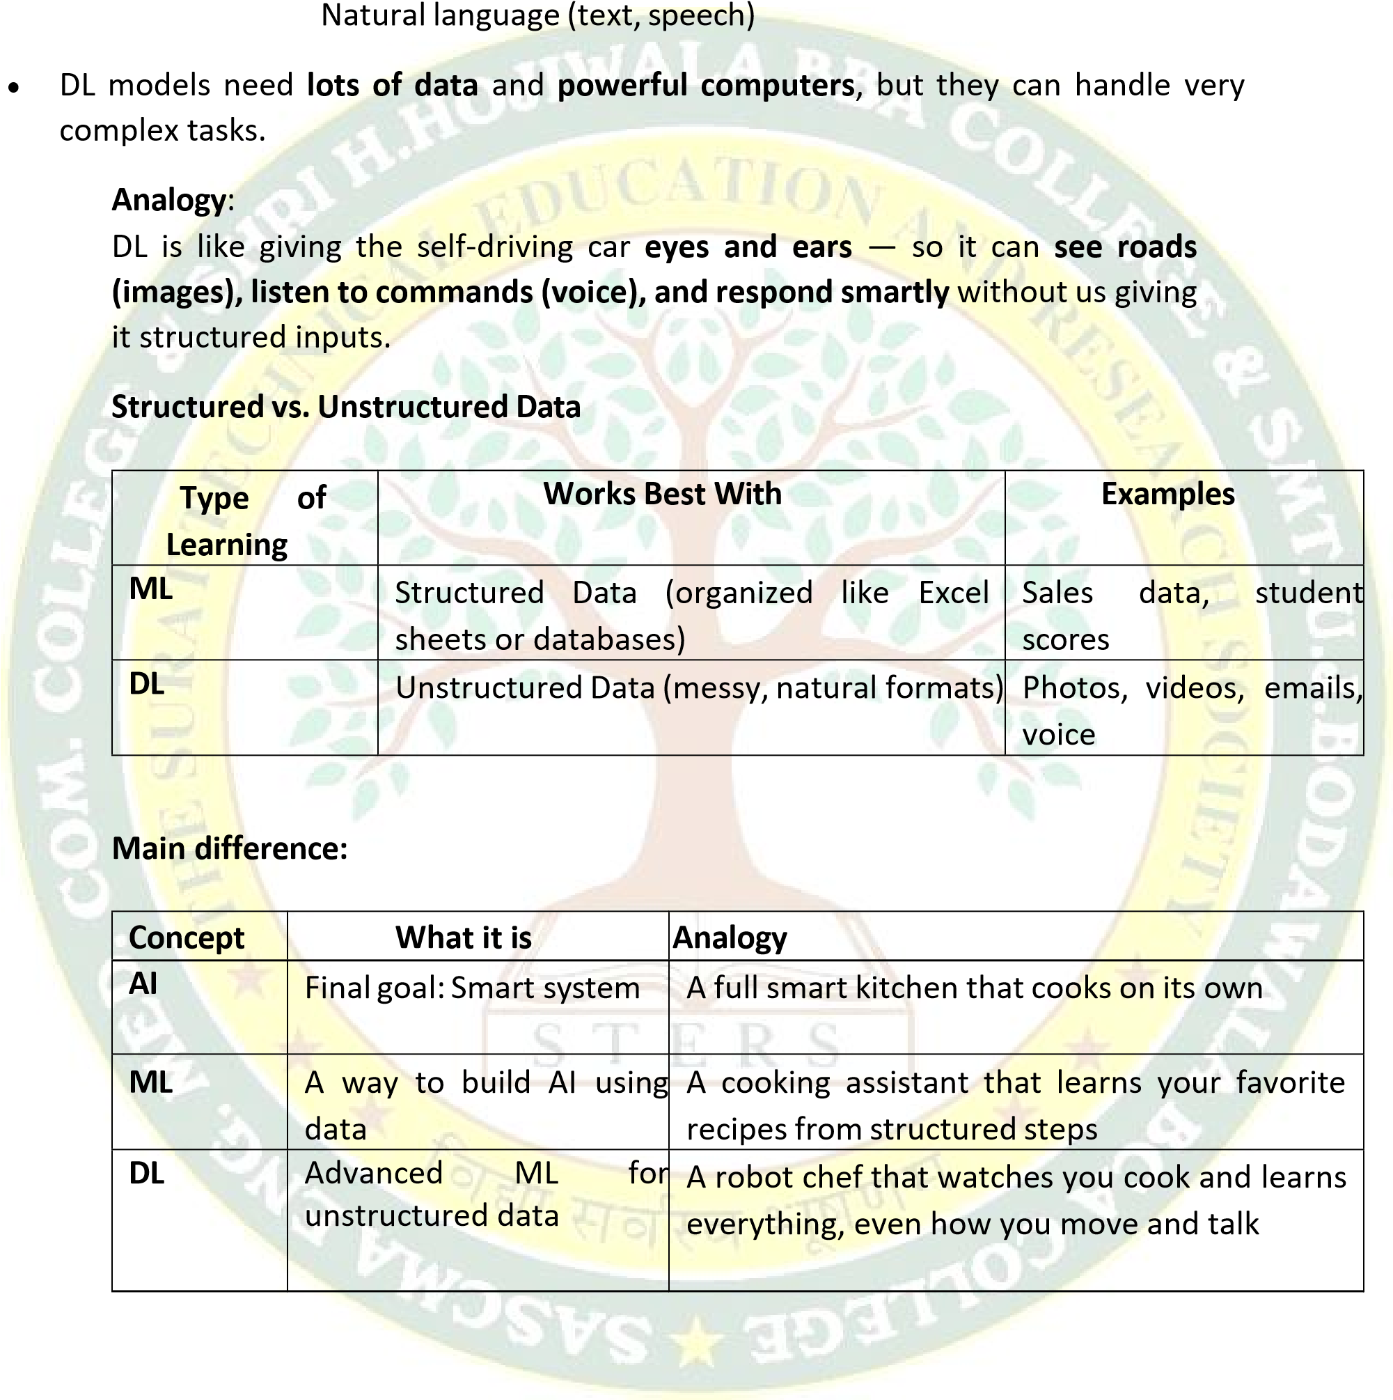o

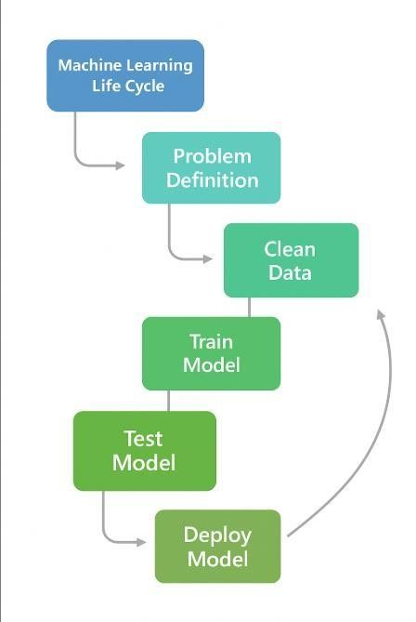

***1.2***

***Machine learning Life Cycle***

**1.2.1**

**Stages of ML Life Cycle**

The

Machine

Learning

(

ML

)

Life

Cycle

refers to the

**step**

**-**

**by**

**-**

**step process**

of

building,

training,

testing,

and

deploying

an

ML

model

to

solve

a

real

-

world

problem using data.

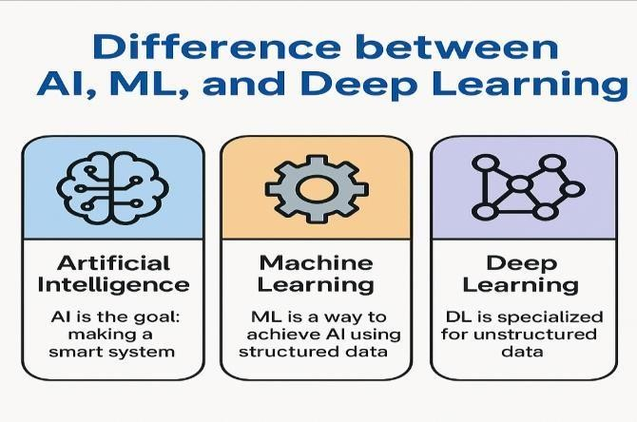

**1. Problem Definition**

**What it means:**

Define clearly what problem you are trying to solve with ML. Without a clear goal, the project will fail.

**Examples:**

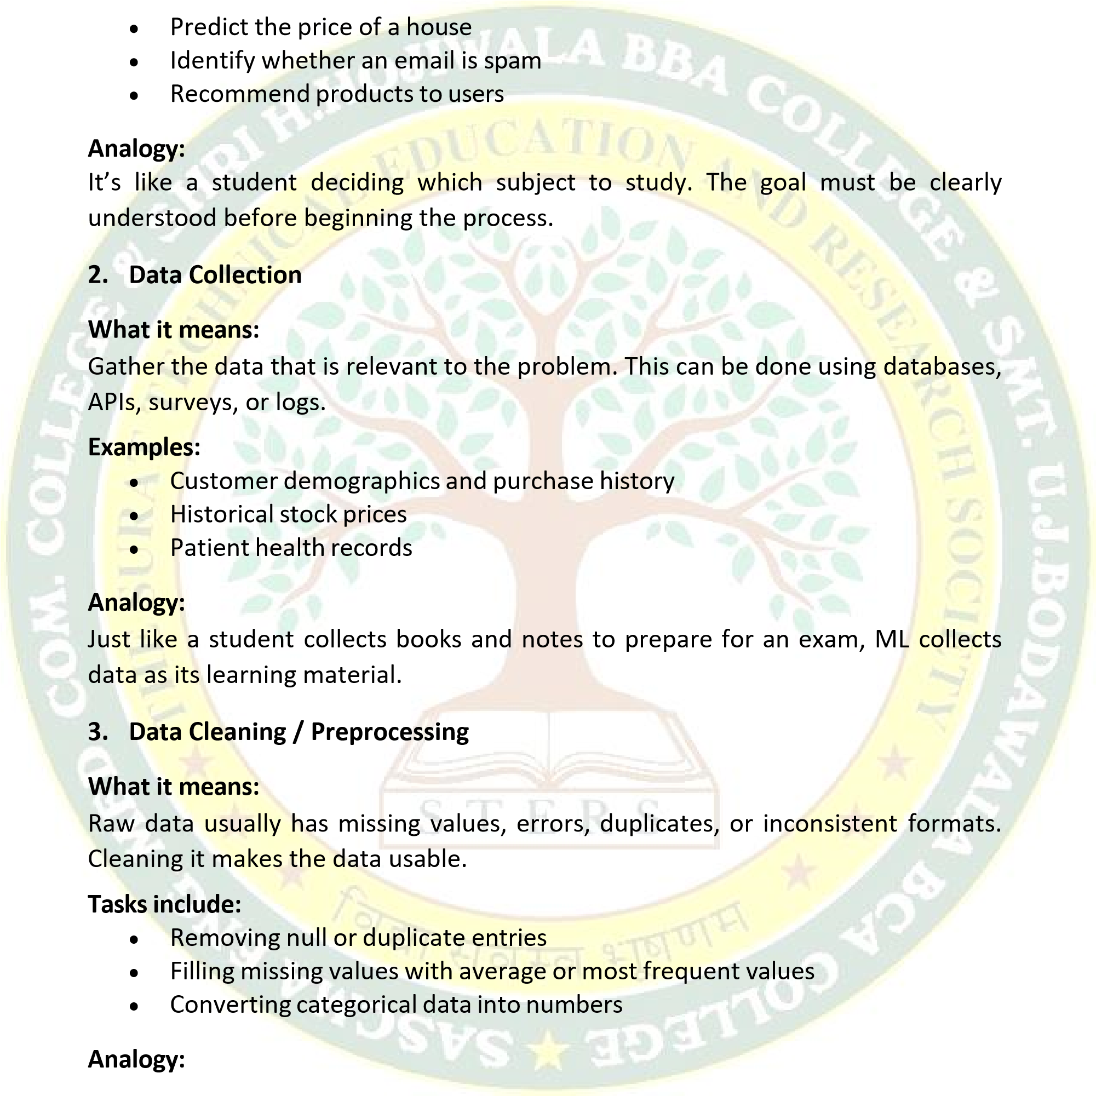

Like organizing and rewriting messy notes before studying.

**4. Feature Selection and Engineering**

**What it means:**

Choose the most relevant variables (features) for the model and sometimes create new ones that help improve model performance.

**Examples:**

* + Selecting “age” and “income” for a loan model
  + Creating “total_marks” from multiple subject scores

**Analogy:**

Similar to summarizing your syllabus into key points so you can study better.5

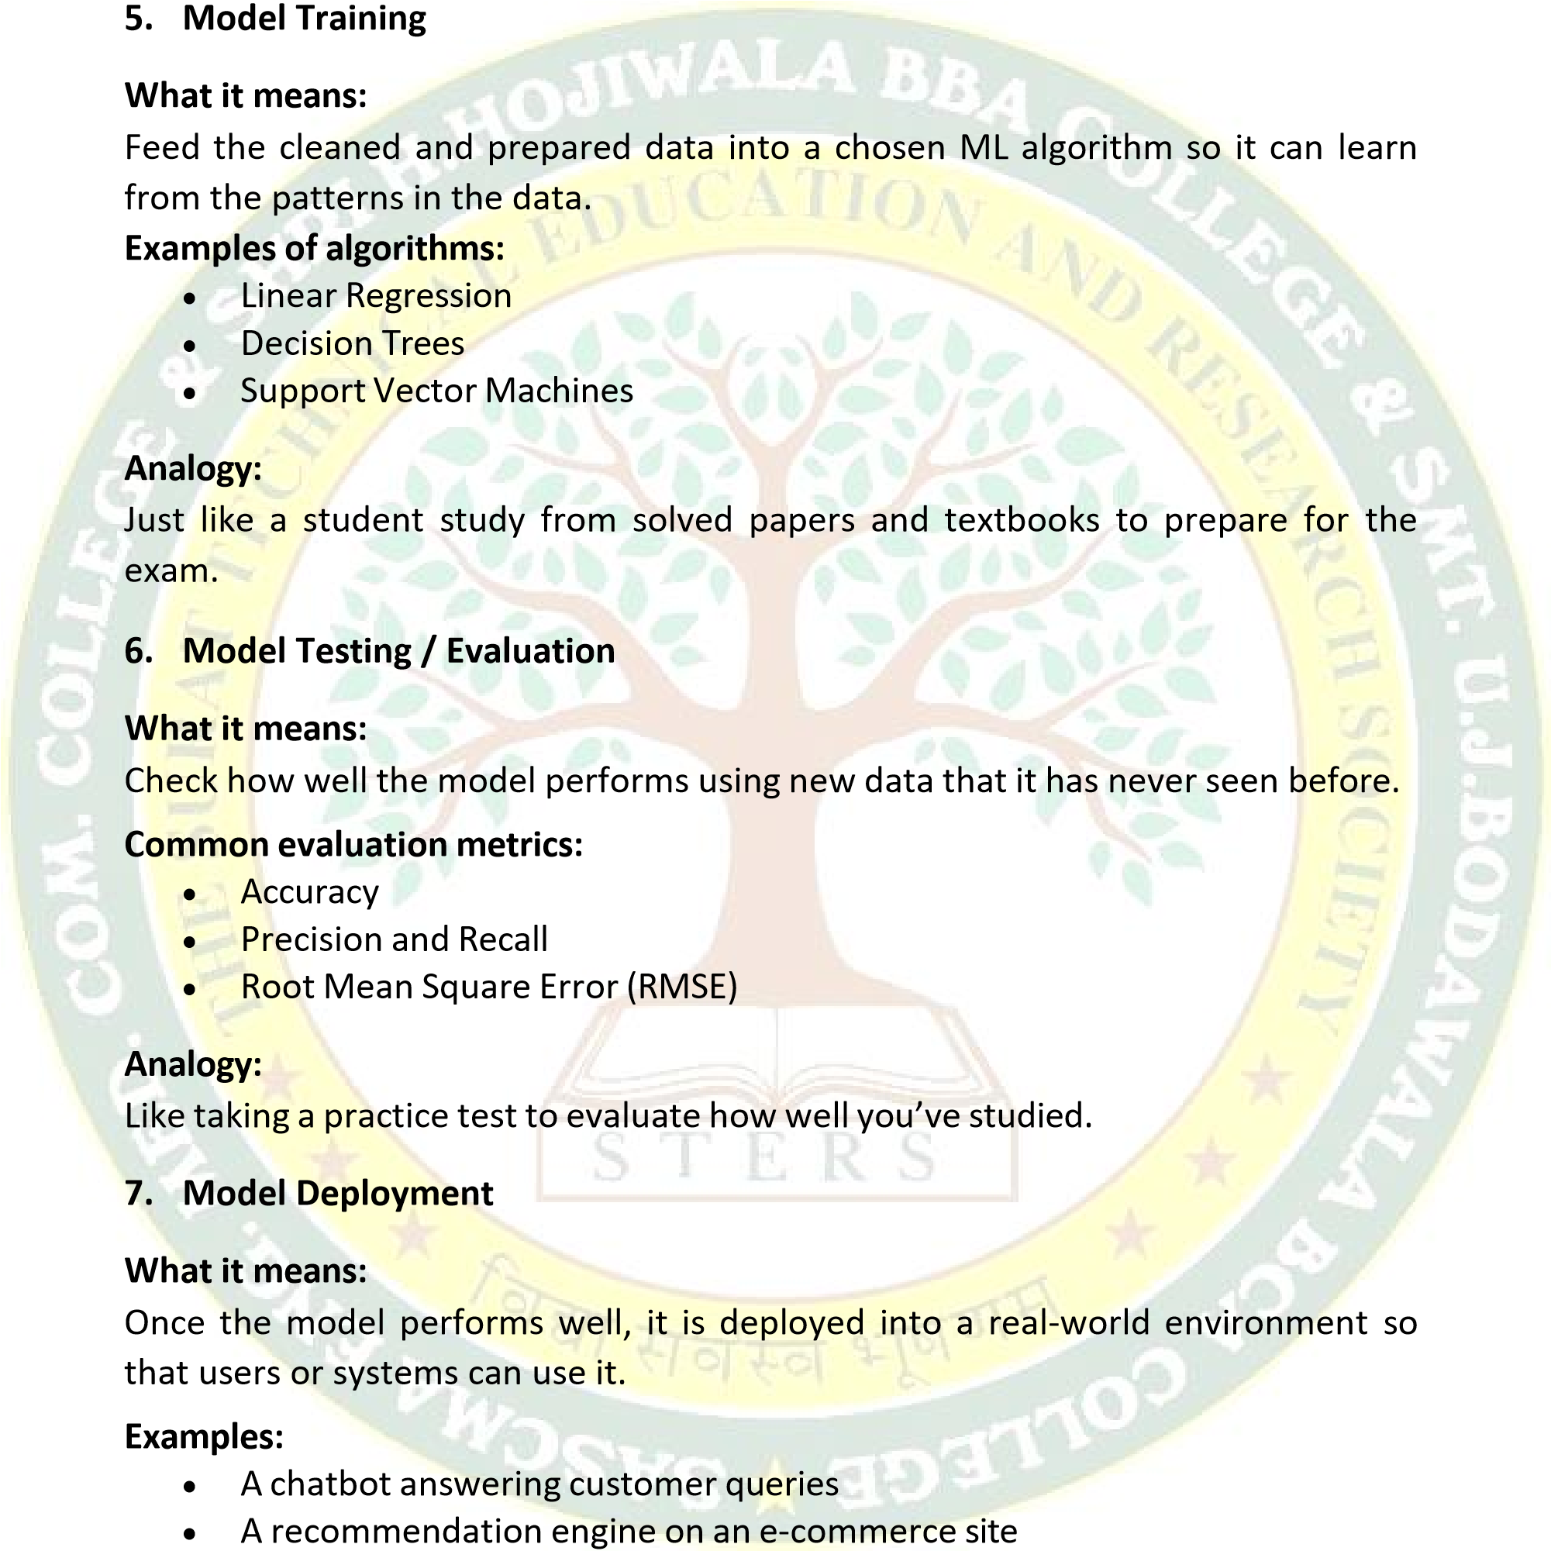

**Analogy:**

Like taking the final exam or presenting your project to a panel.

**8. Monitoring and Maintenance**

**What it means:**

Even after deployment, the model needs to be checked regularly. If it becomes less accurate due to changing data, it must be retrained or updated.

**Examples:**

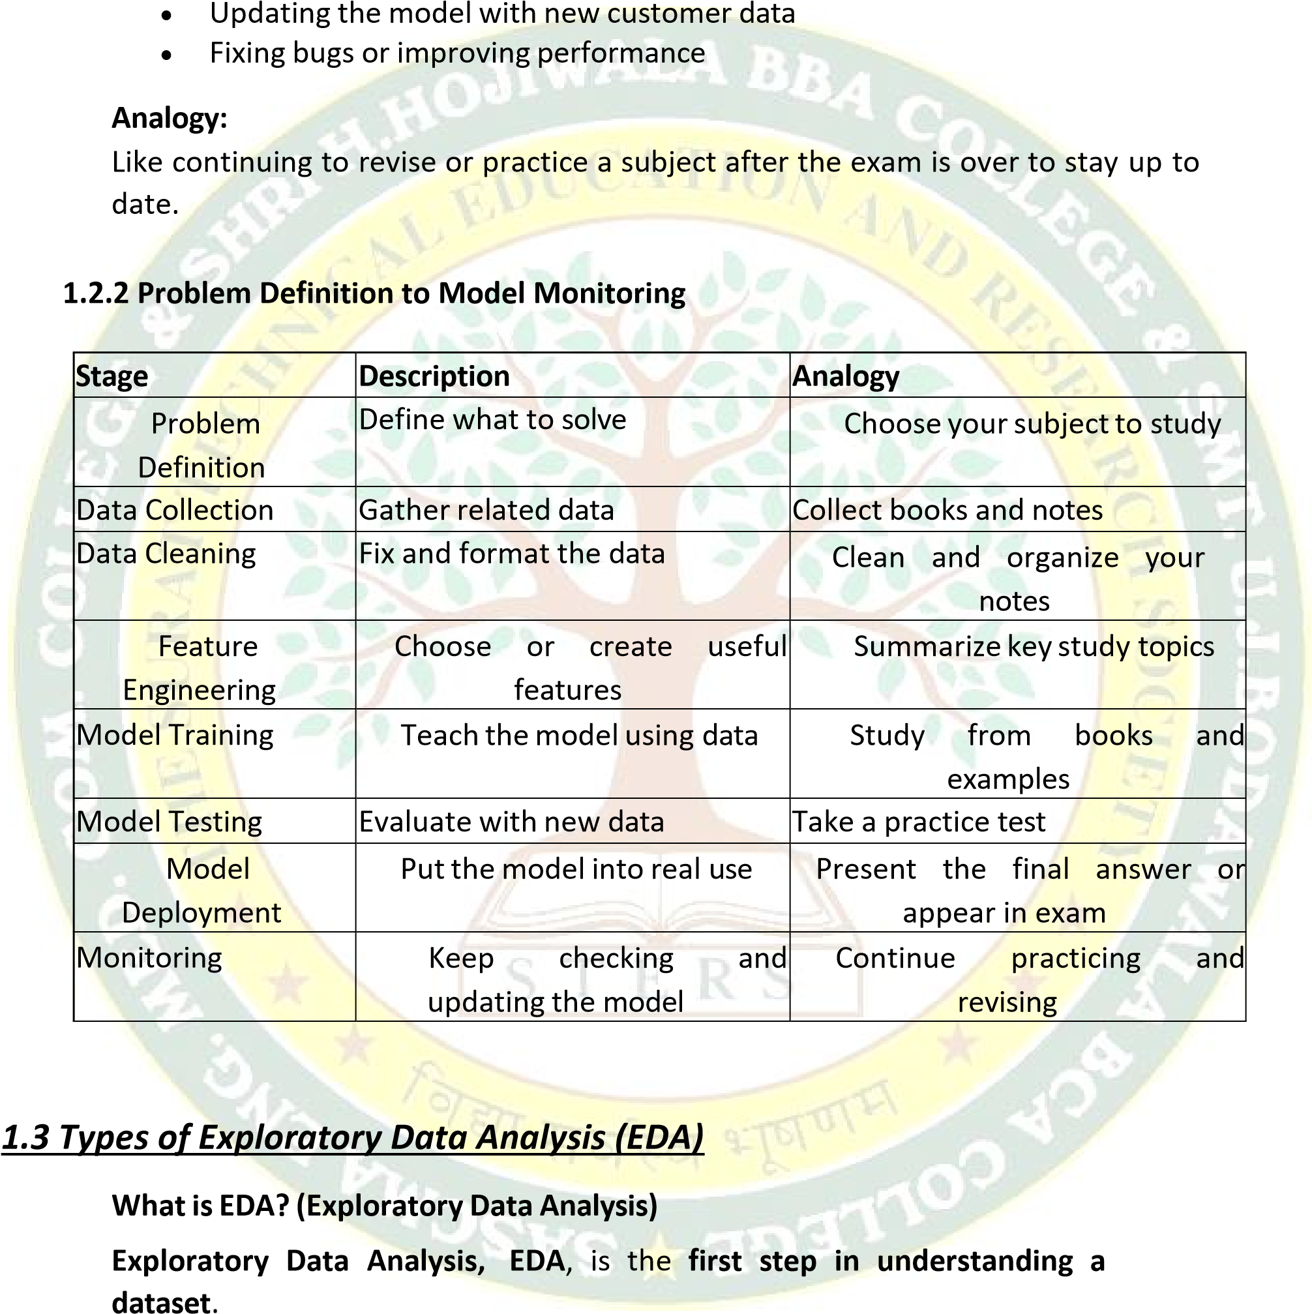

Before we build any machine learning model, we must explore the data to:

* Understand what's in it
* Find patterns or trends
* Spot mistakes, missing values, or unusual data (outliers)

**Think of it like checking ingredients before cooking a dish** — you want to know

what you have, what’s good, and what needs to be cleaned or removed.

**1.3.1 Types of Exploratory Data Analysis (EDA)**

Exploratory Data Analysis (EDA) can be divided into three main types based on the number of variables being analyzed:

* Univariate Analysis
* Bivariate Analysis
* Multivariate Analysis

**Univariate analysis**:

focuses on analyzing a single variable at a time. It helps us understand the basic properties of that variable such as its distribution, central values (like mean and median), and spread (like range or standard deviation). For example, if we want to explore the marks scored by students in a class, we will look at one column (marks) and use tools like histograms or box plots to understand how those marks are distributed.

**Bivariate analysis:**

involves the study of two variables to explore the relationship or correlation between them. It helps us find whether two variables move together

(positive or negative correlation), or how one affects the other. For instance, we might analyze the relationship between "hours studied" and "marks scored" to see if studying more results in higher marks. Common tools for bivariate analysis include scatter plots, correlation coefficients, and line graphs.

**Multivariate analysis:**

deals with three or more variables at the same time. It is used when we want to explore more complex patterns and interactions within the data. For example, we might study how a student’s marks are affected by multiple factors like study hours, sleep time, and attendance. This kind of analysis is especially useful in machine learning when many input features are used to predict an output. Visualization tools such as heatmaps, pair plots, and 3D scatter plots are often used in multivariate analysis.

In summary, univariate analysis gives us information about each individual variable, bivariate analysis reveals how two variables relate to each other, and multivariate analysis helps us understand relationships and patterns among several variables at once.

**1.3.2 Univariate Analysis**

**What is Univariate Analysis?**

Univariate analysis means analyzing **one variable at a time**.

The term "uni" means **one**, and "variate" refers to a **variable** (or a column in a dataset). So, univariate analysis is all about **understanding the properties and patterns of a single variable** without involving any other variable.

**It helps us answer questions like:**

* What kind of values does the variable take?
* What is the average value? o Is the data spread out or tightly packed? o Are there any very high or very low values (outliers)?

**There are two types of variables** in univariate analysis:

* 1. **Numerical (continuous or discrete)** – like marks, height, age, salary
  2. **Categorical( non Numerical)** – like gender, city, product category

**Depending on the type of variable, we use different techniques**:

* + **For numerical variables**, we calculate: o Mean (average) o Median (middle value) o Mode (most frequent value) o Range, Variance, Standard Deviation o We also plot **histograms** and **box plots**
  + **For categorical variables**, we look at: o Frequency count (how many times each category appears) o Percentages or proportions
* We use **bar charts** and **pie charts** to visualize

In short, univariate analysis gives us a **basic understanding of one column** of data. It is often the first step before analyzing relationships between variables (which is done in bivariate or multivariate analysis).

**Univariate Analysis Example**

**Let’s say we are working with a dataset named “Students Performance in Exams”** that contains student information such as:

* + Gender
  + Math score
  + Reading score
  + Writing score

**Now, let’s perform univariate analysis** on one variable:

**Example 1: Numerical Variable – Math Score** We

want to analyze the column **“math score”**. **We can ask:**

What is the average math score?

|  |
| --- |
| import pandas as pd import matplotlib.pyplot as plt  df=pd.read_csv("StudentsPerformance.csv")  print(df['gender'].value_counts()) data=df['gender'].value_counts() plt.bar(data,height=20) plt.show() |

Are there any students scoring very low or very high?



import pandas as pd

import matplotlib.pyplot as plt

df=pd.read_csv("StudentsPerformance.csv")

print(df['math score'].describe())

plt.hist(df['math score'],bins=10, edgecolor='black')

plt.show()

What

is

the

highest

and

lowest

score?

Are

most

students

scoring

between

60

and

?

80

**We**

**can**

**use:**

•

**Descriptive**

**statistics**

like

mean,

median,

max,

min

•

**Histogram**

to

see

the

distribution

•

**Box**

**plot**

to

detect

outliers

**Code:**

**Example**

**2:**

**Categorical**

**Variable**

**(**

**)**

**Non Numerical**

**–**

**Gender**

Now

we

analyze

the

column

**“gender”**

.

We can

ask:

•

How

many

male

and

female

students

are

there?

•

Which

gender

is

more

in

the

class?

We can use:

•

**Value**

**counts**

to

get

the

frequency

•

**Bar**

**chart**

to

visualize

**Code**

:

**Bivariate and Multivariate Analysis - Extended**

In data analysis, understanding how variables relate to each other is crucial. Bivariate and multivariate analyses help us

explore relationships between two or more variables in a dataset. This document

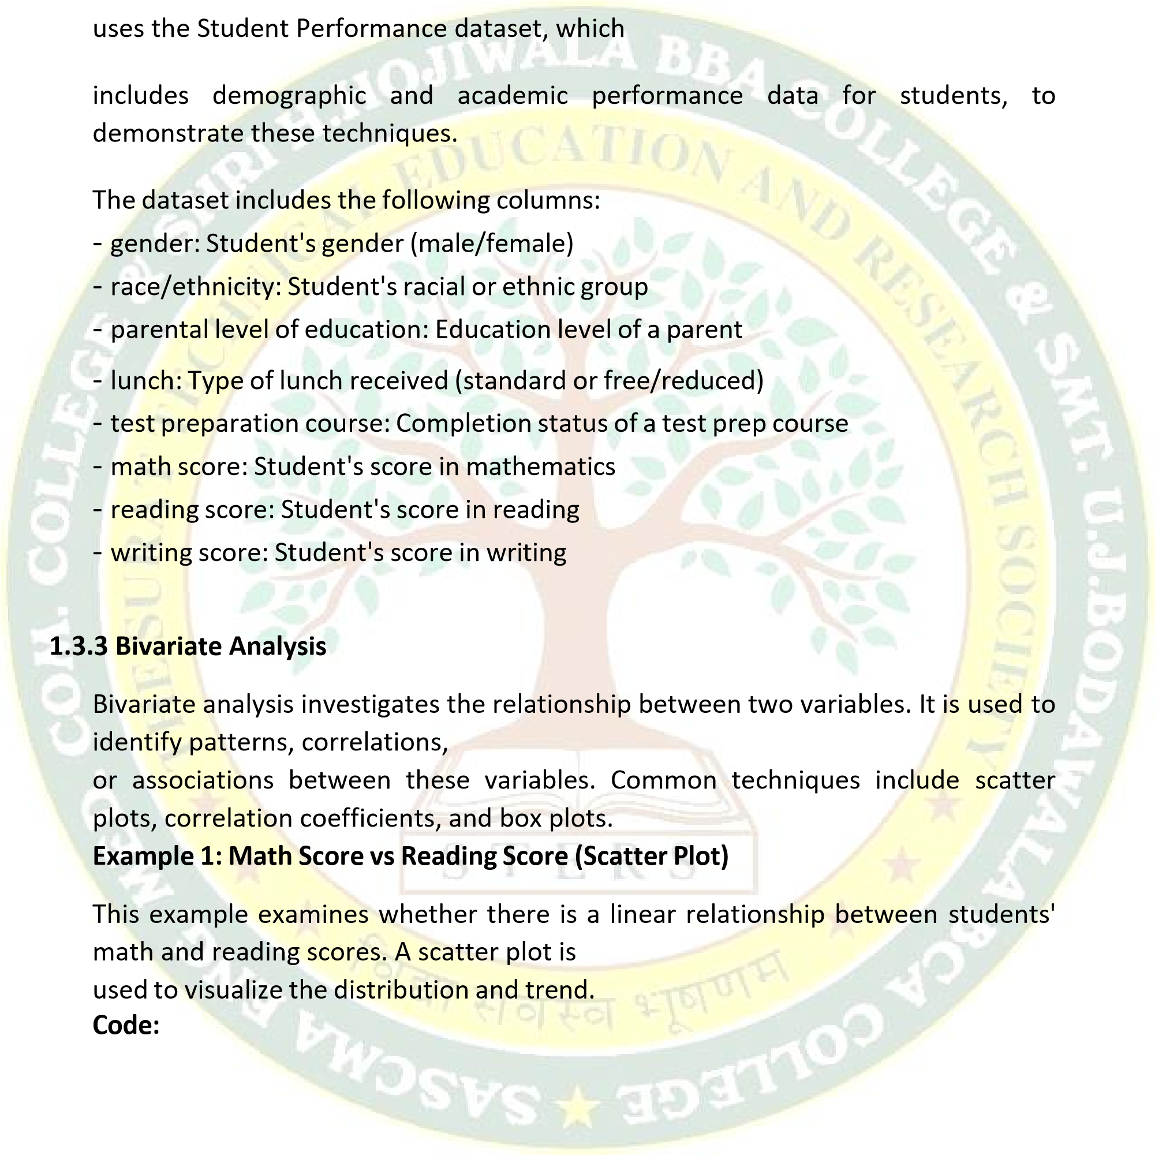



import pandas as pd

import matplotlib.pyplot as plt

import seaborn as sns

df = pd.read_csv

)

"StudentsPerformance.csv"

(

sns.scatterplot(data=df, x='math score', y='reading score')

plt.title('Math Score vs Reading Score')

plt.xlabel('Math Score')

plt.ylabel('Reading Score')

plt.grid(True)

plt.show()

import pandas as pd

import matplotlib.pyplot as plt

import seaborn as sns

df = pd.read_csv("StudentsPerformance.csv")

sns.boxplot(data=df

, x='gender', y='writing score')

plt.title('Gender vs Writing Score')

plt.xlabel('GENDER')

plt.ylabel('WRITING Score')

plt.show()

**Interpretation:**

If

the

points

form

an

upward

trend,

this

indicates

a

positive

correlation

—

students who perform well in math also tend

to

perform

well

in

reading.

**Example**

**2:**

**Gender**

**vs**

**Writing**

**Score**

**(**

**Box**

**Plot)**

This

example

evaluates

if

gender

has

an

impact

on

writing

scores

using

a box

plot,

which

shows

the

spread

and

central

tendency

of

the

scores

for each

gender.

**Code:**

**Interpretation:**

The

box

plot

can

reveal

differences

in

medians,

spread,

and

outliers between

genders.

**1.3.4 Multivariate Analysis**

Multivariate analysis involves examining relationships among three or more variables. It helps in understanding complex

interactions and patterns within the data. Common visual tools include pair plots and heatmaps.

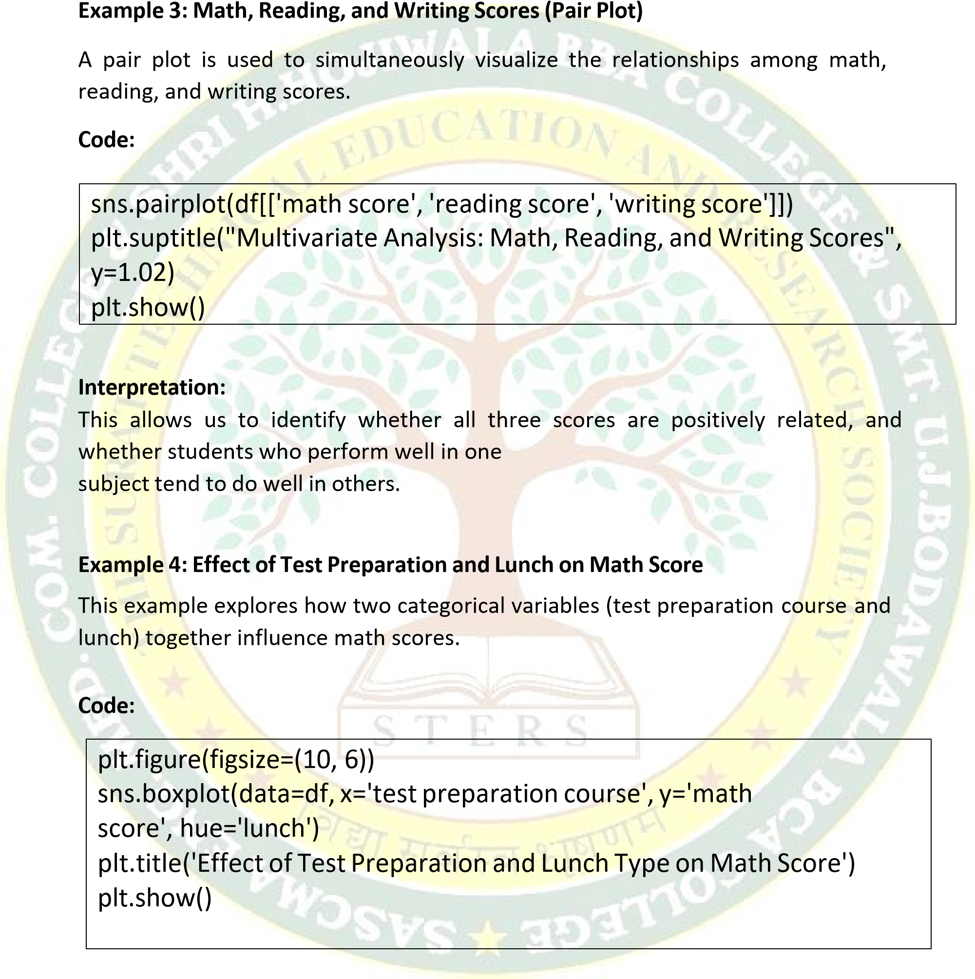

**Interpretation:**

By grouping the data, we can observe combined effects of two categorical variables on the target numeric variable. **Summary:**

* Bivariate analysis focuses on relationships between two variables. It helps in identifying correlations and trends.
* Multivariate analysis allows exploration of complex relationships involving three or more variables.
* Visual tools such as scatter plots, box plots, pair plots, and heatmaps are essential for understanding patterns in data.
* These techniques aid in decision making, feature selection, and predictive.

**1.3.5 Handling Missing Data 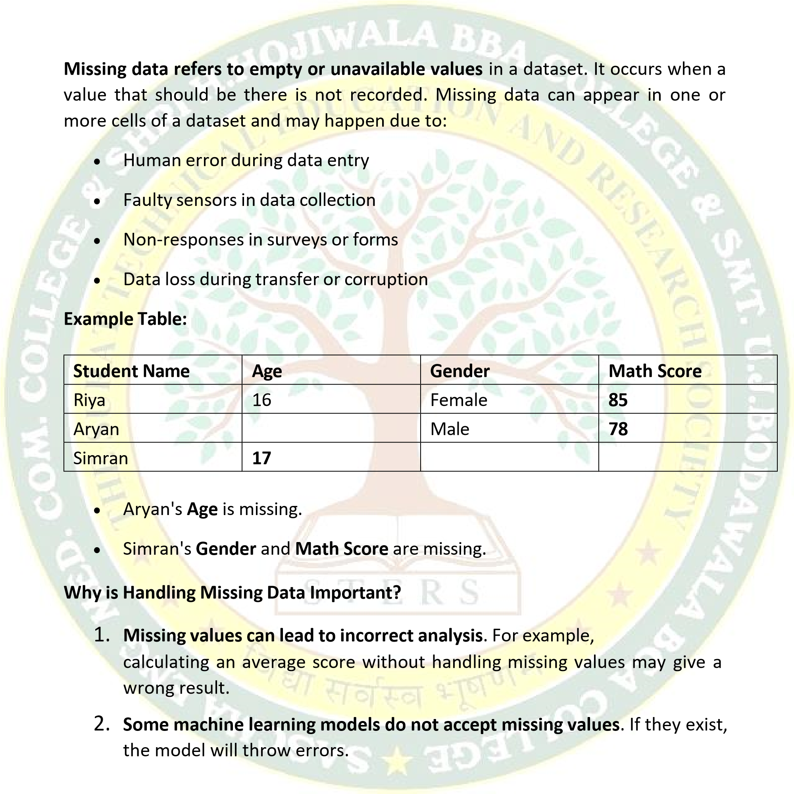What is Missing Data?**

3. **Data quality is reduced**, which affects predictions and decisions made using that data.

Hence, before any analysis or modeling, we must **identify and handle missing values properly**.

**Types of Missing Data**

**Understanding why data is missing helps us choose the best way to handle it. There are three types:**

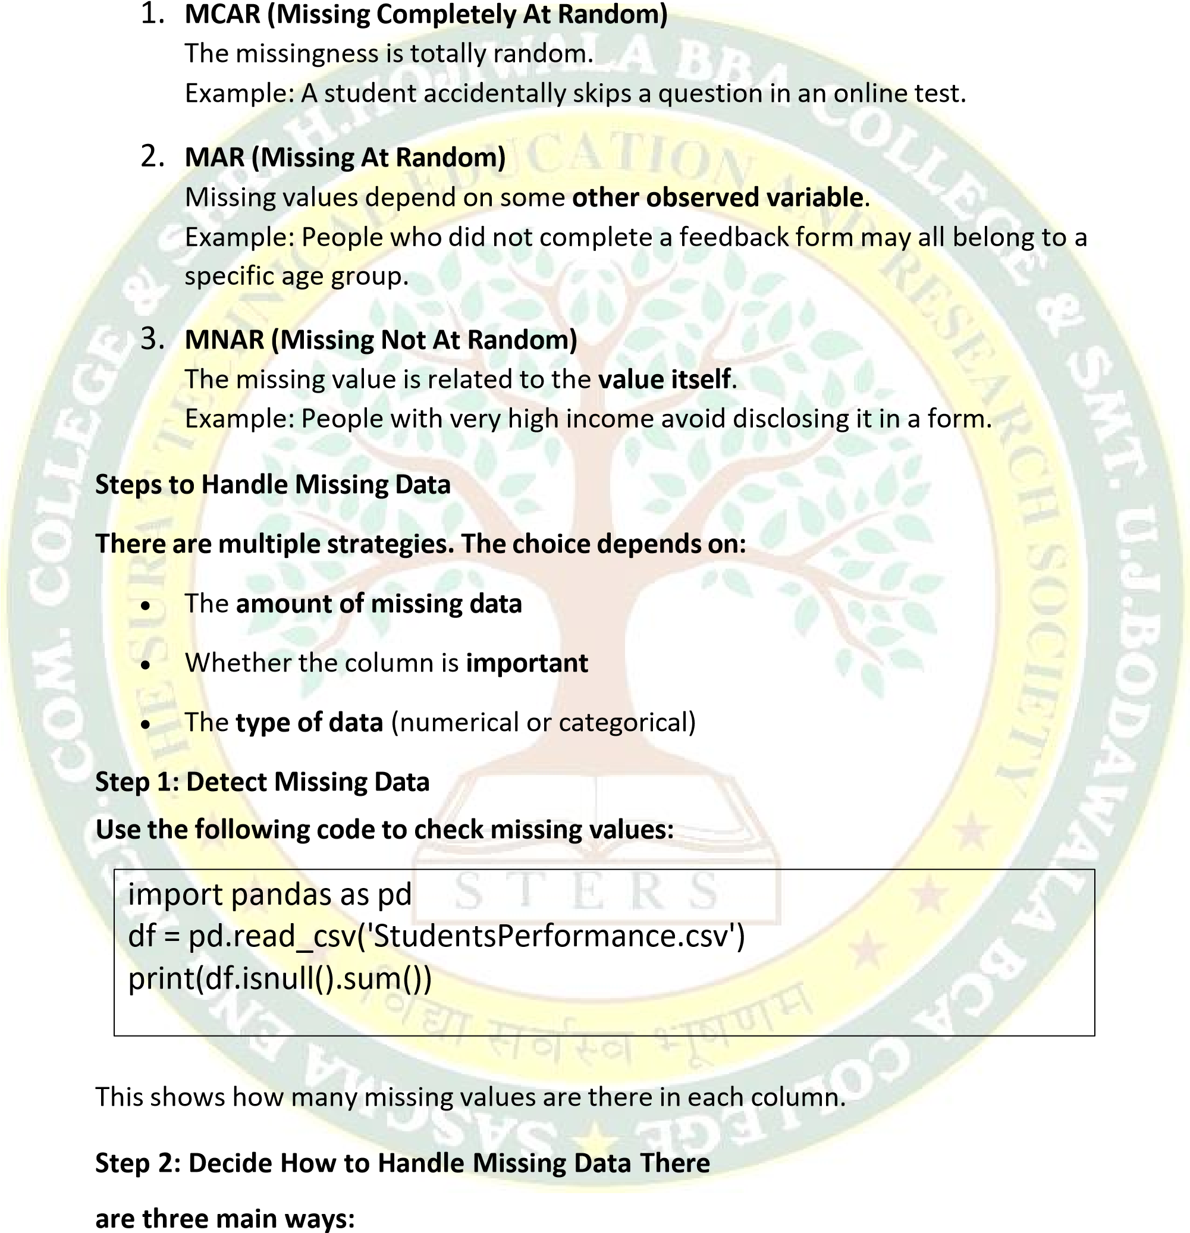

**A. Deletion (Dropping Rows or Columns)**

1. **Drop Rows – Removes rows that contain any missing value.**

df.dropna(inplace=True)

**Use this when:**

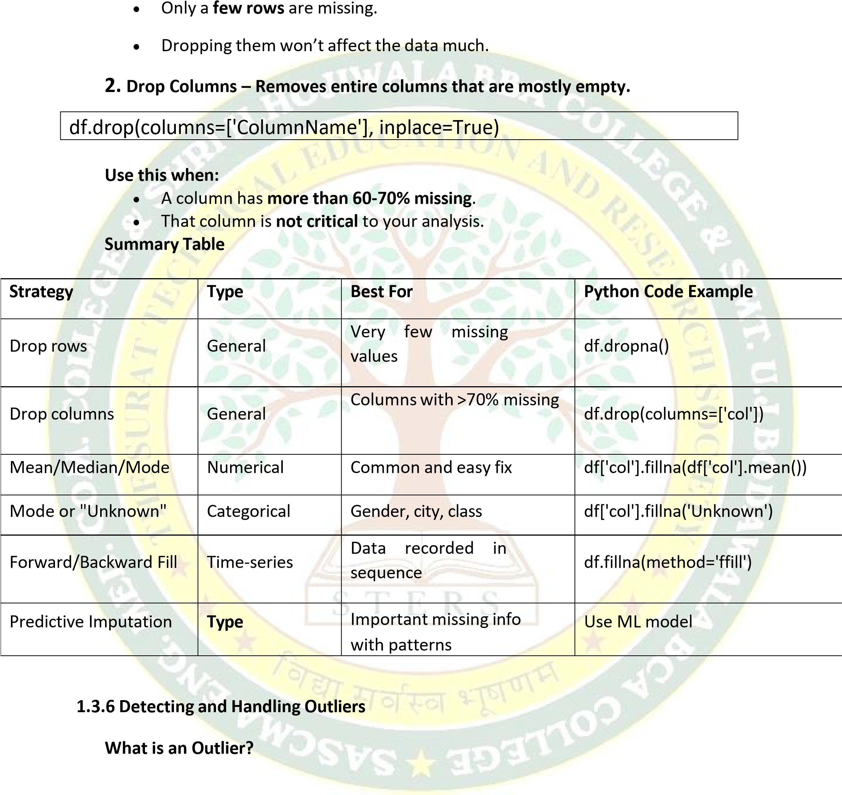An **outlier** is a data point that is **significantly different** from the rest of the data. It is **unusually high or low** and does not follow the pattern of the other values.

**Example:**

If most students scored between 60 and 90 in an exam, but one student scored **0** or **100**, that score may be an **outlier**.

**Why Do Outliers Matter?**

|  |
| --- |
| mean = df['Age'].mean() std = df['Age'].std()  outliers = df[(df['Age'] > mean + 3*std) | (df['Age'] < mean - 3*std)] |

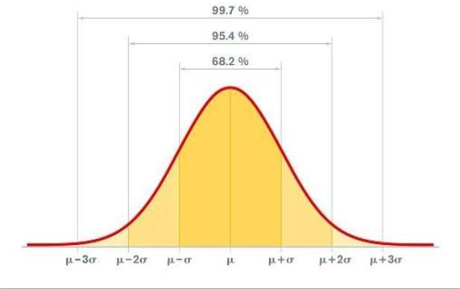

**Outliers can:**

•

**Mislead**

**statistical**

**summaries**

like

mean

and

standard

deviation

•

**Affect**

**visualizations**

(

e.g.,

they

stretch

the

scale)

•

**Negatively**

**impact**

**machine**

**learning**

**models**

,

especially

those

that use

distance

-

based algorithms like linear regression or k

-

means

clustering

So,

it’s

important

to

**detect**

and

decide

whether

to

**handle**

**or**

**keep**

them.

**Common**

**Causes**

**of**

**Outliers**

•

**Data**

**entry**

**errors**

(

e.g.,

typing

1000

instead

of

100)

•

**Measurement**

**errors**

(

e.g.,

faulty

sensor)

•

**Genuine**

**extreme**

**values**

(

e.g.,

millionaire

income

in

a

population)

**Methods**

**to**

**Detect**

**Outliers**

**1.**

**Using**

**Descriptive**

**Statistics**

Calculate

**mean**

and

**standard**

**deviation**

.

A

value

far

from

the

mean

(

typically > 3 standard deviations) is considered an outlier.

1. **Using Interquartile Range (IQR) Method (Most common)** 
   * + - * IQR = Q3 - Q1

The **Interquartile Range (IQR)** method is a **robust and commonly used** technique to detect

outliers, especially when the data is **not normally distributed**.

* + - * + **Q1 (1st Quartile):** 25% of the data lies **below** this value.
        + **Q3 (3rd Quartile):** 75% of the data lies **below** this value.
        + **IQR (Interquartile Range):** Measures the **spread of the middle 50%** of the data.
        + Outliers are data points **below Q1 – 1.5 × IQR** or **above Q3 + 1.5 × IQR**

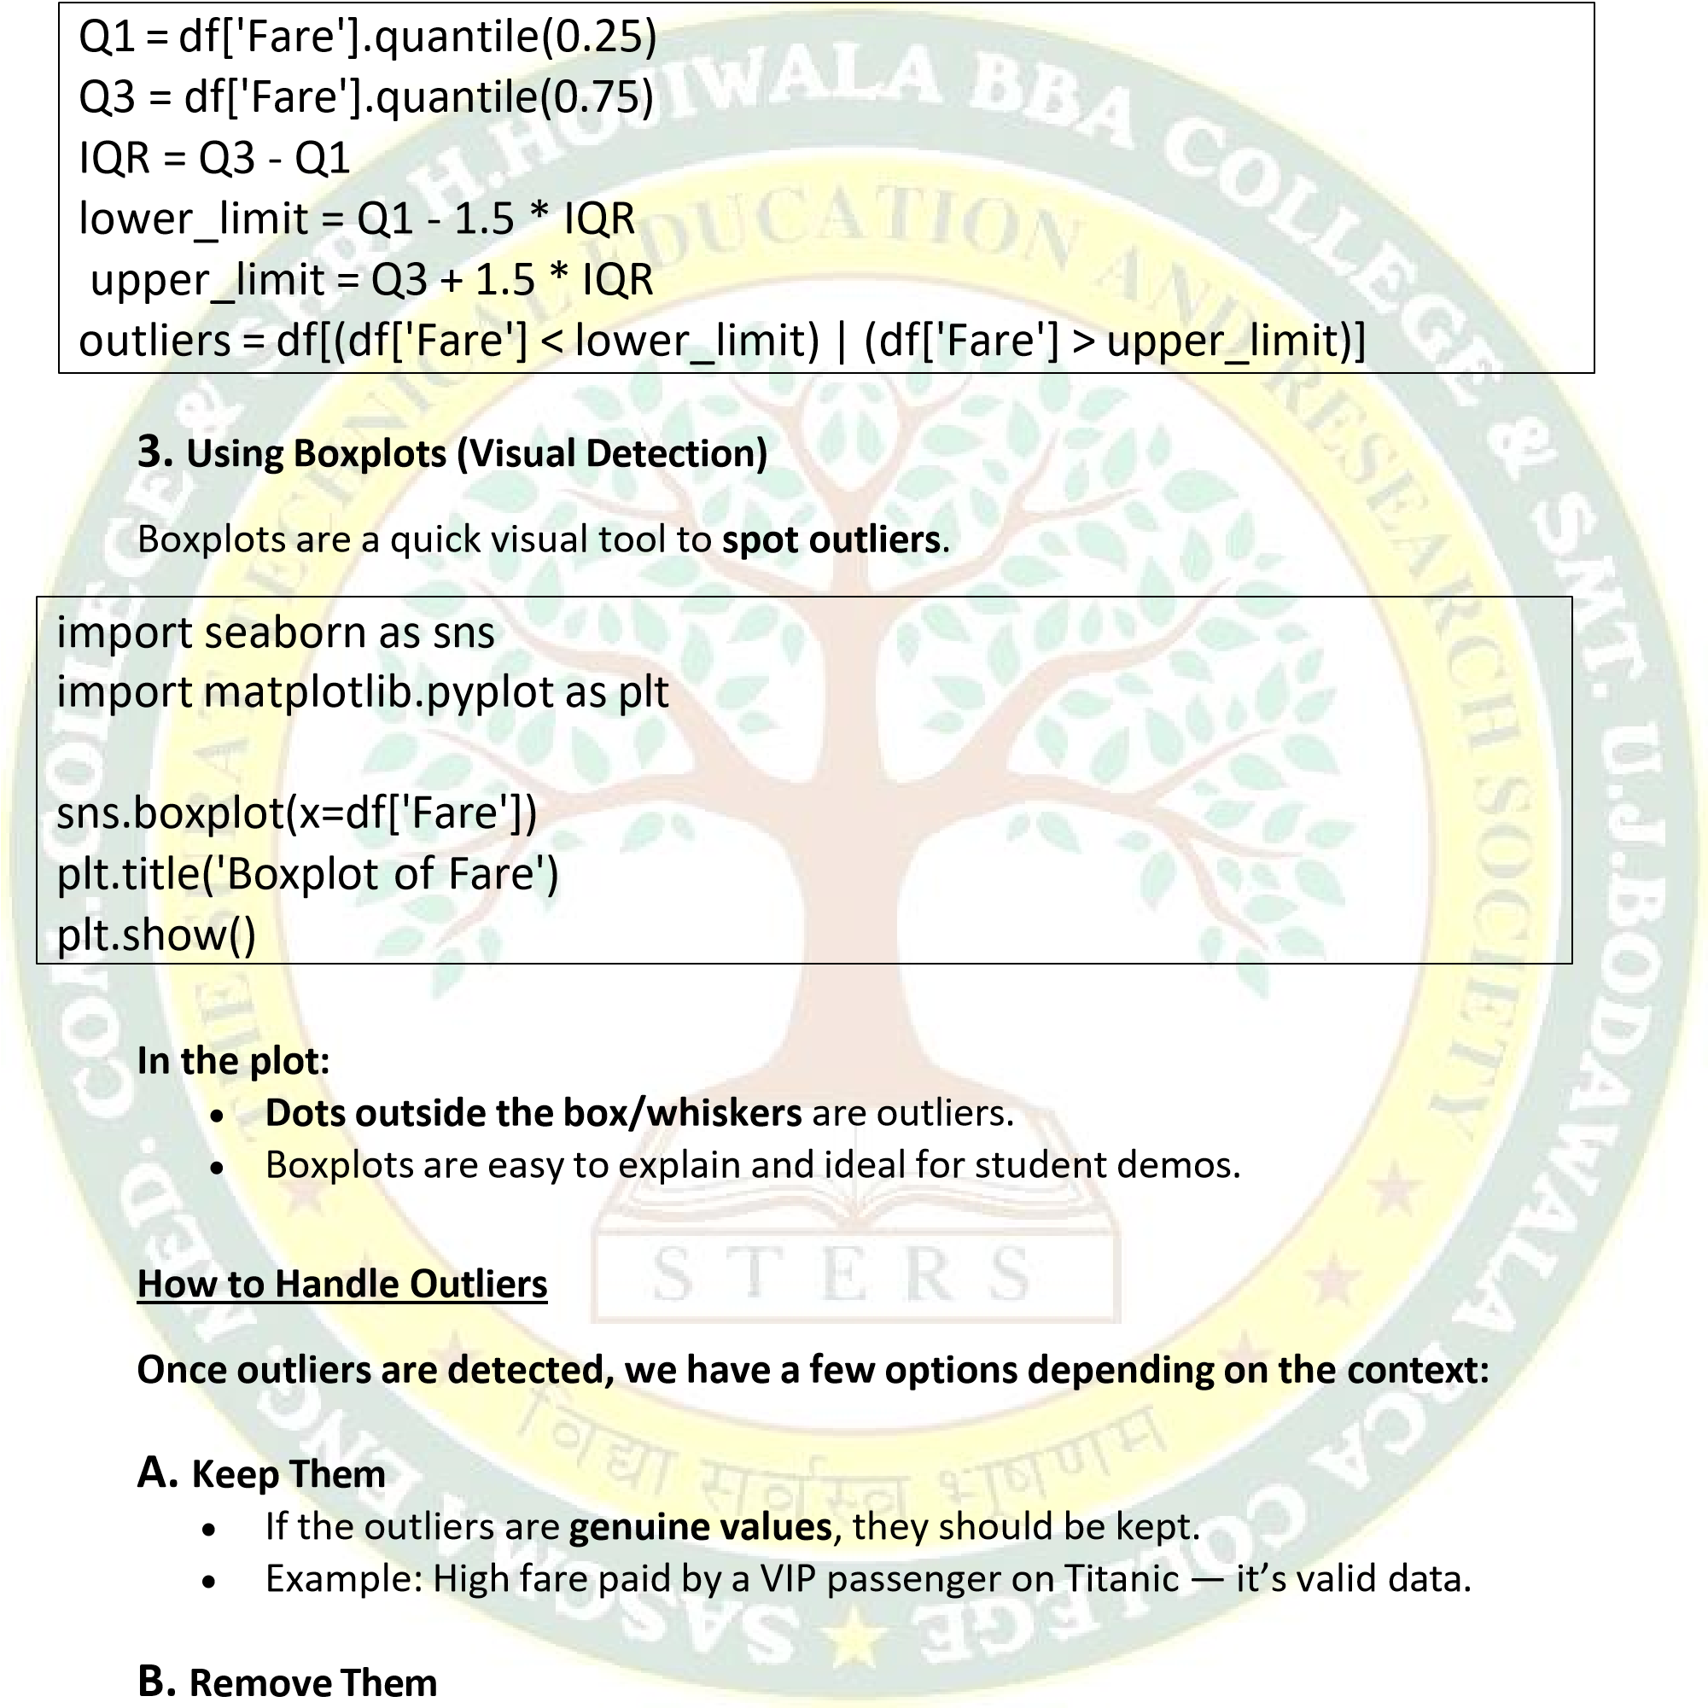

* + - * + If outliers are due to **errors or noise**, remove them to prevent skewing results.

# Remove outliers using IQR

df = df[(df['Fare'] >= lower_limit) & (df['Fare'] <= upper_limit)]

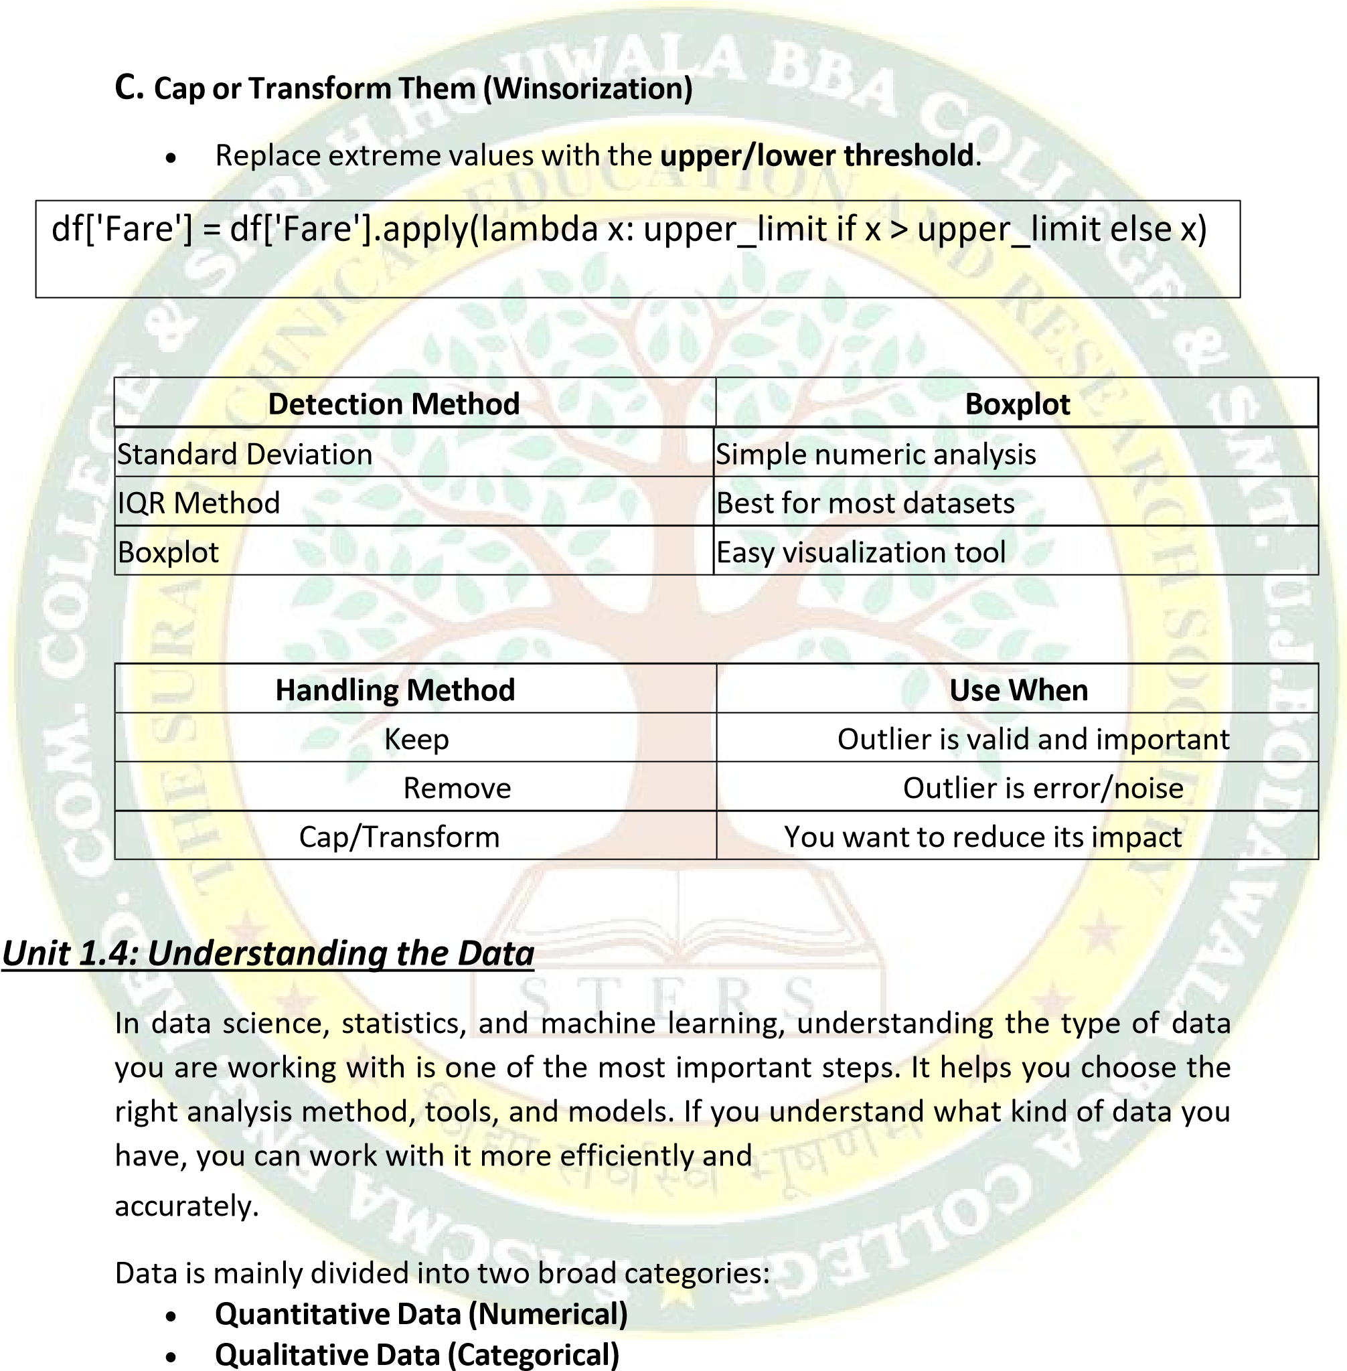

Let us now understand each type in detail in simple words with lots of examples to make things clearer.

**1.4.1 Quantitative Data (Numerical Data)**

Quantitative data is data that deals with **numbers**. It answers questions like:

* + - * + How much? • How many?
        + What is the value?

You can **count** or **measure** this type of data. Since it is in numeric form, you can do math on it. For example, you can add, subtract, find the average, etc.

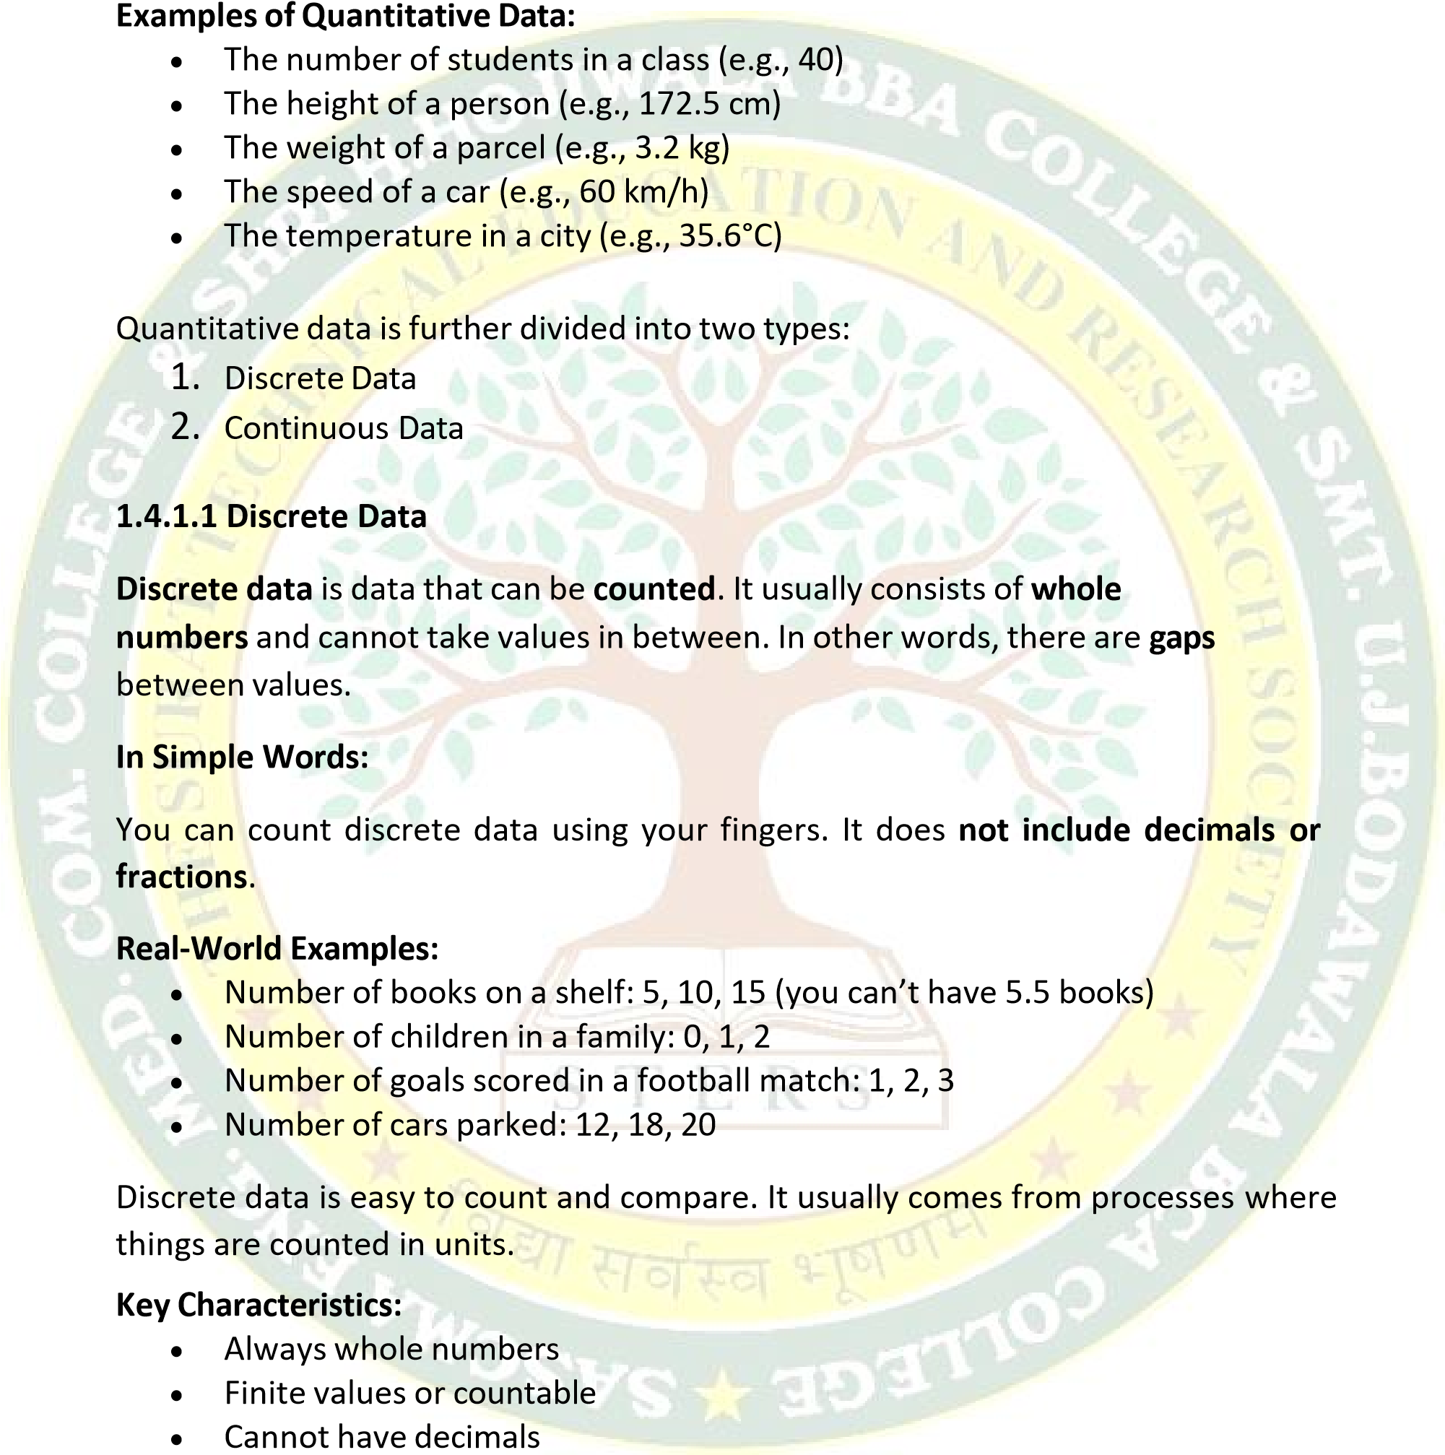

**Useful Tip:**

If you are **counting something** and the result is a **whole number**, it’s likely to be discrete data.

**1.4.1.2 Continuous Data**

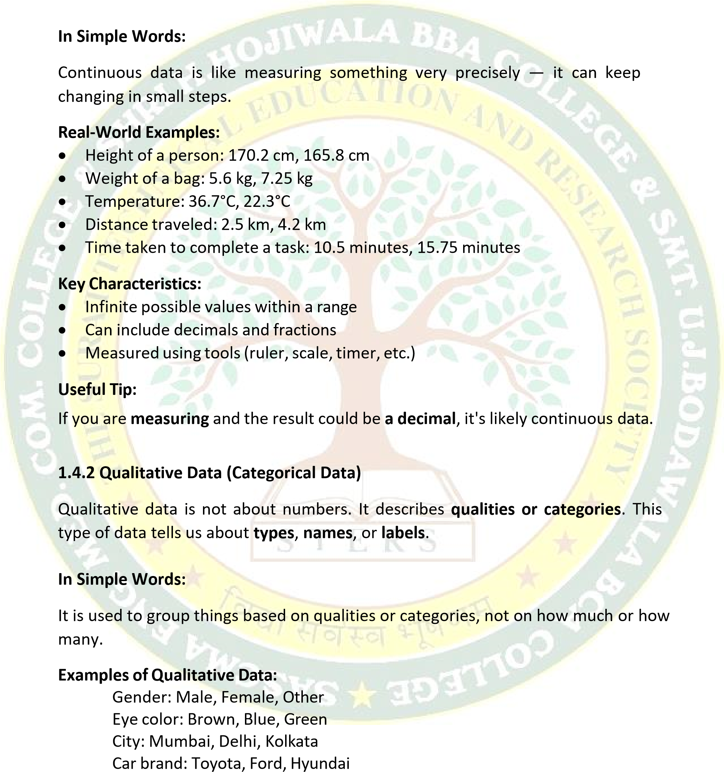**Continuous data** is data that can be **measured**, and it can take **any value** within a range. It can have **decimals and fractions**, and the values are not limited to whole numbers.

•

•

•

•

You cannot do math on qualitative data. You cannot add two eye colors or average the names of cities.

Qualitative data is further divided into:

* + - * 1. Nominal Data
        2. Ordinal Data

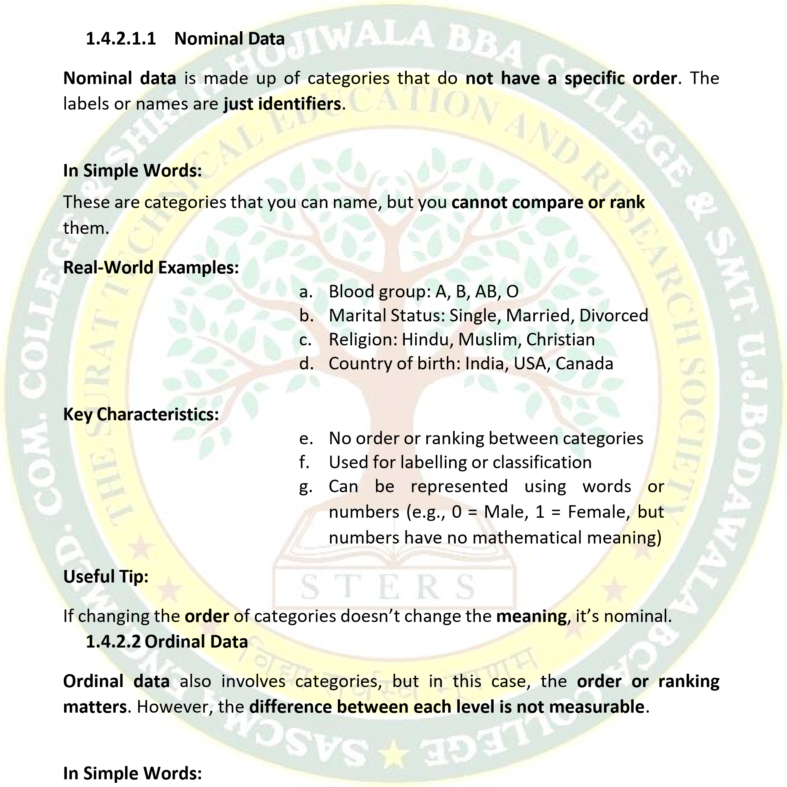

These are categories that you can **rank** or **order**, but you don’t know how much better one is than the other.

**Real-World Examples:**

* + - * Education level: High School < Bachelor’s < Master’s < PhD
      * Customer satisfaction: Poor < Fair < Good < Excellent
      * Class rank: First, Second, Third
      * Spicy level: Mild < Medium < Hot

**Key Characteristics:**

* + - * Categories have a meaningful order
      * No measurable gap between levels
      * Used when ranking is more important than the actual value

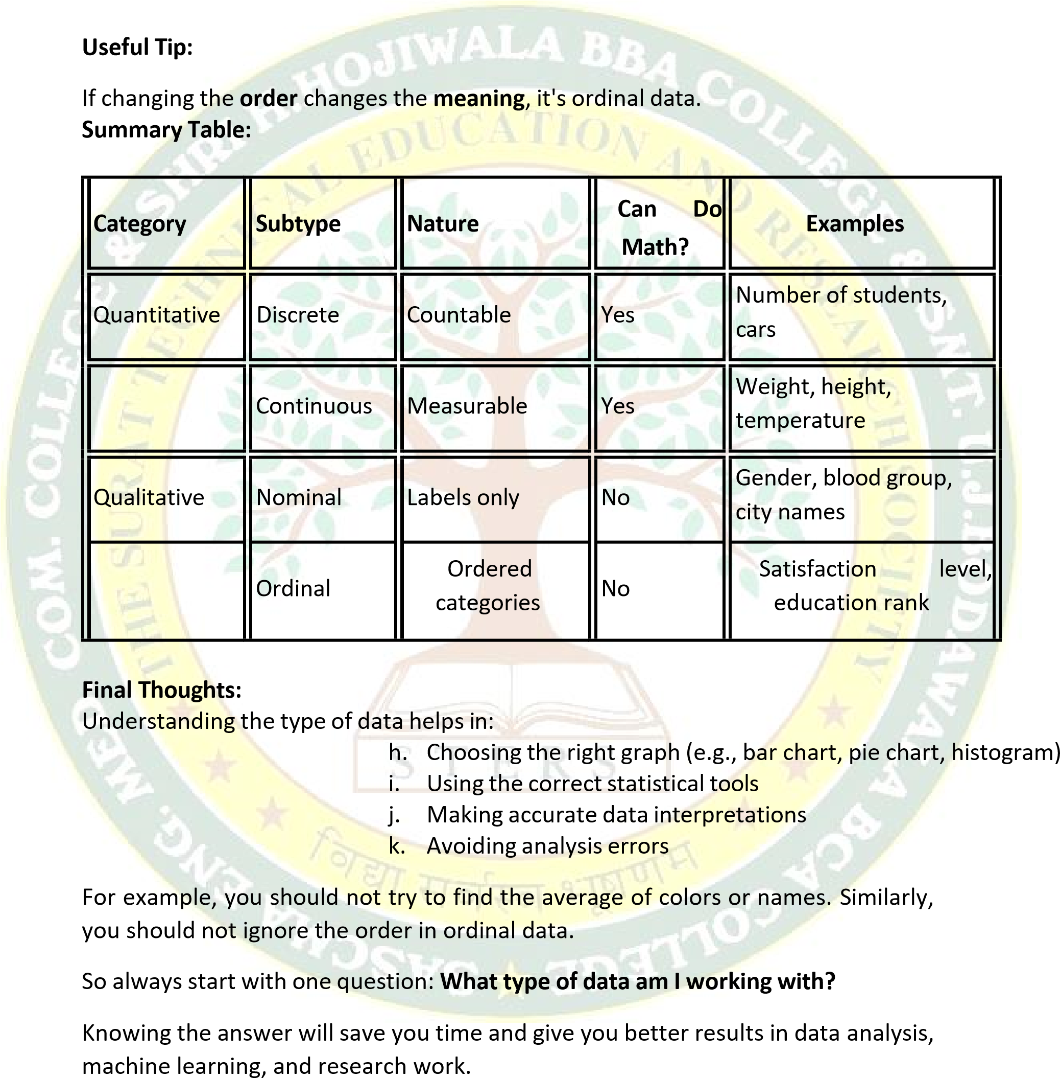

# 1.5 Spread of Data

Includes:

* Normal Distribution
* Skewed Distribution
* Skewness
* Kurtosis

**What is "Spread of Data"?**

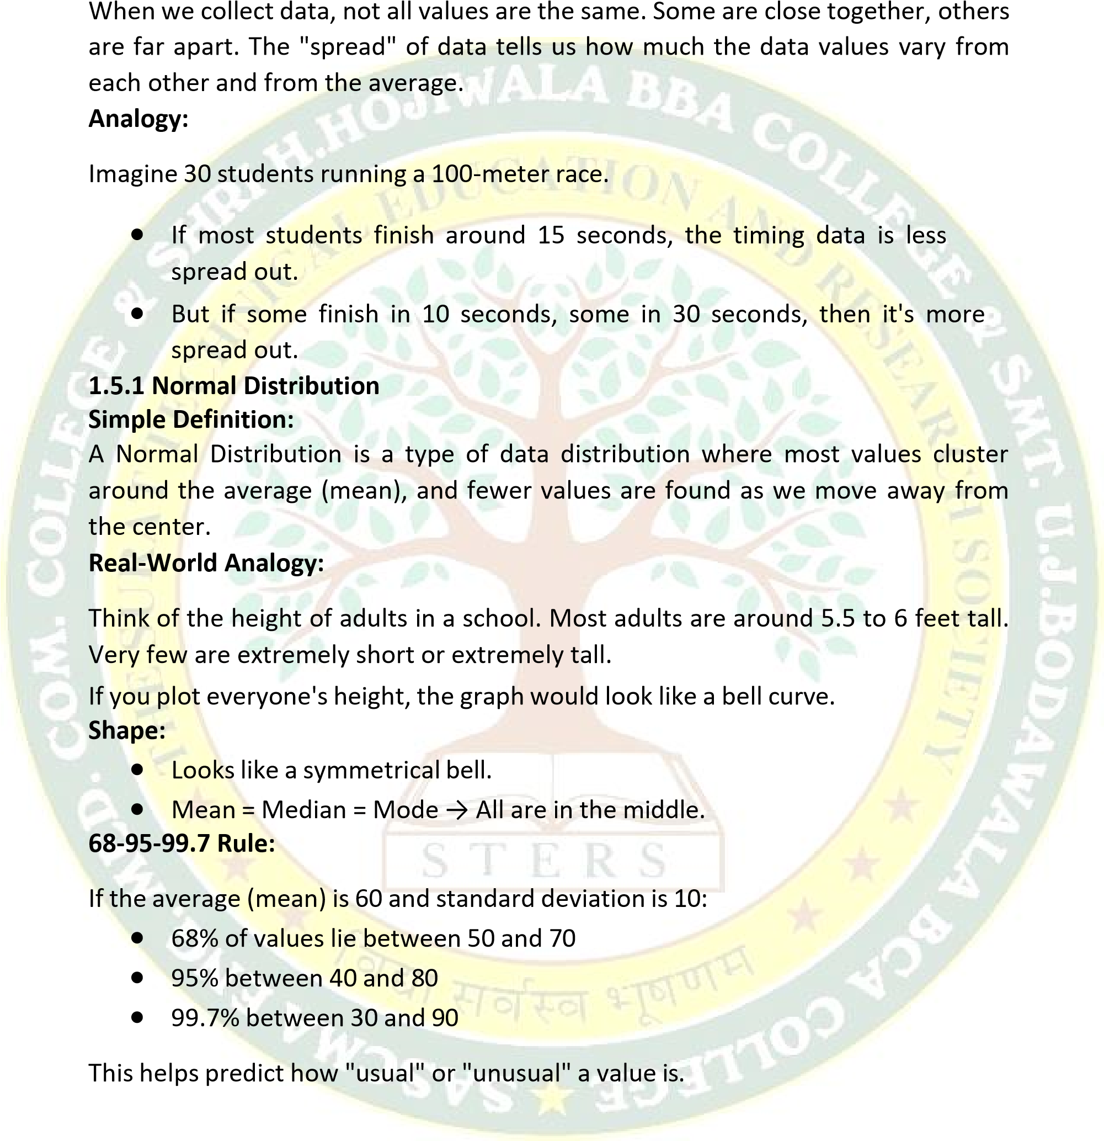

**1.5.2 Skewed Distribution Simple Definition:**

A Skewed Distribution happens when data is not evenly spread around the average. One side has more values or longer tails.

There are two types of skewed distributions:

**1. Positively Skewed (Right-Skewed) Analogy:**

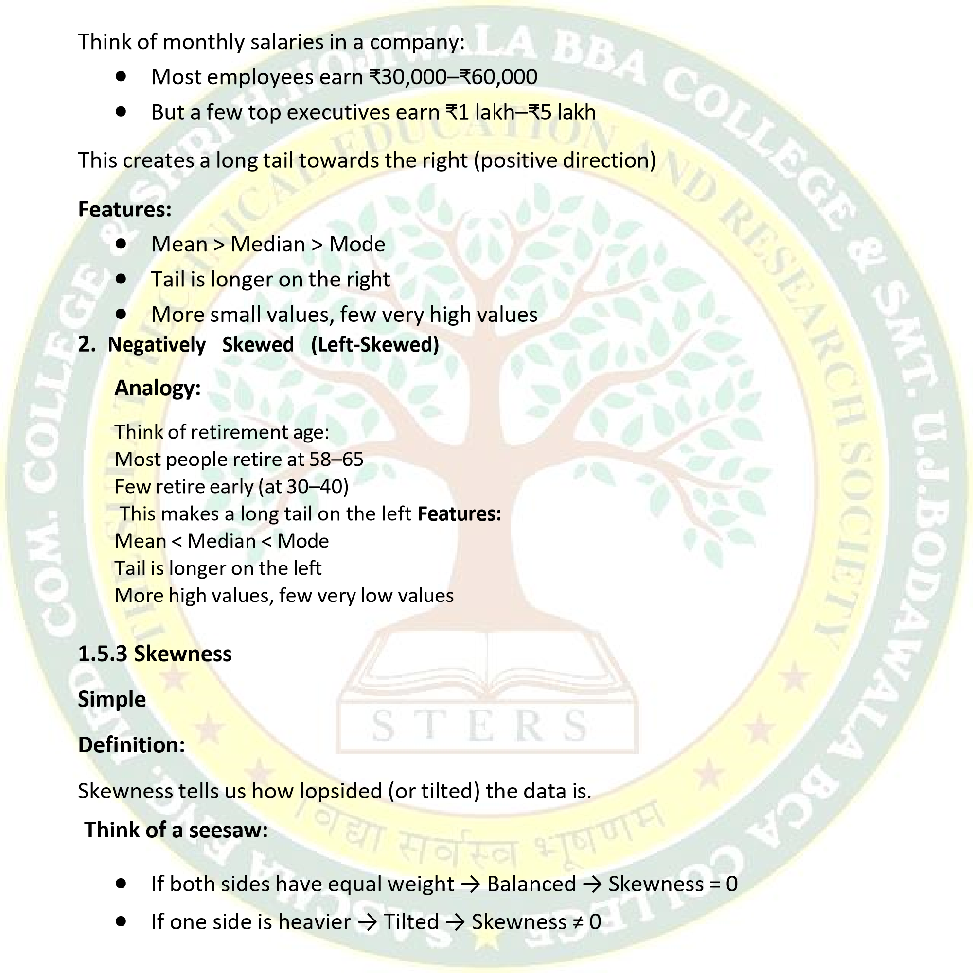

**Types of Skewness:**

|  |  |  |
| --- | --- | --- |
| **Skewness Value** | **Shape** | **Meaning** |
| **0** | **Perfectly symmetrical** | **Normal distribution** |
| **> 0** | **Tail to the right** | **Positively skewed** |
| **< 0** | **Tail to the left** | **Negatively skewed** |

|  |  |  |  |
| --- | --- | --- | --- |
| **Type** | **Shape** | **Outliers** | **Example** |
| **Mesokurtic** | **Normal (bell)** | **Moderate** | **Heights of adults** |

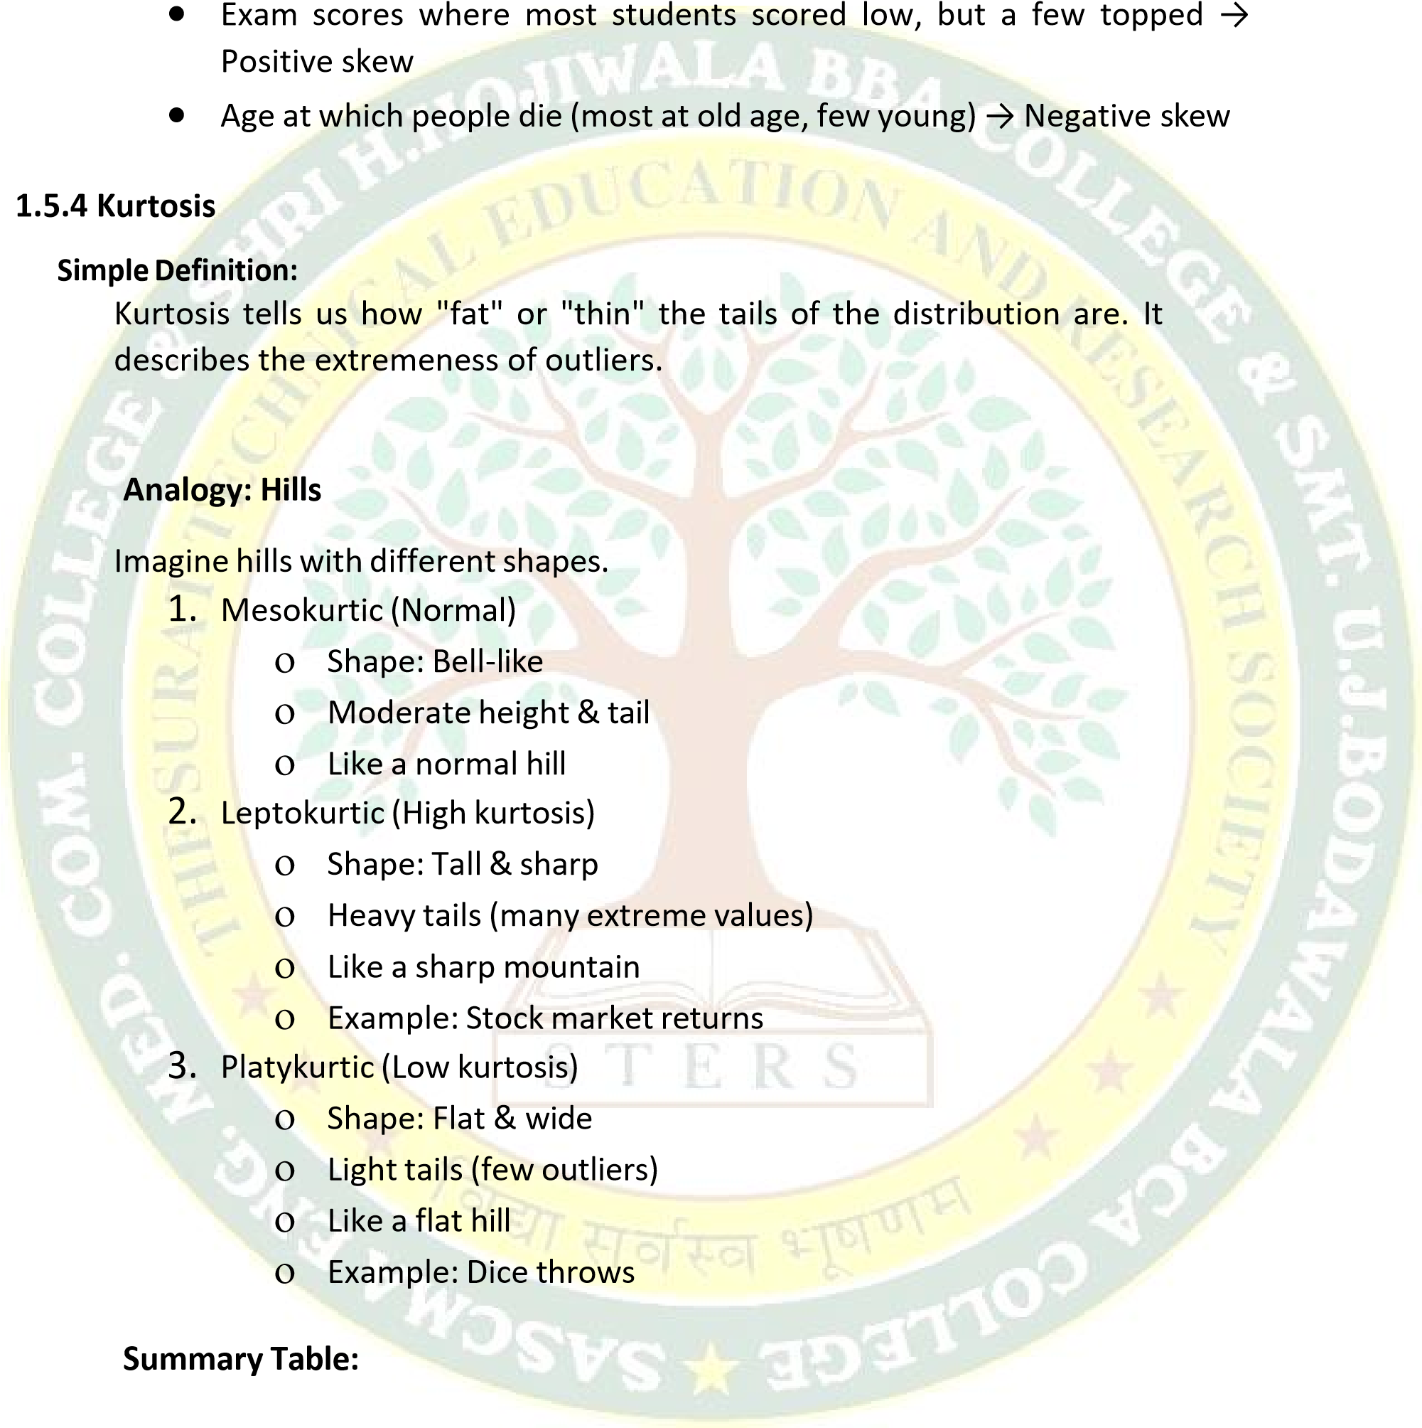**Real-Life Examples:**

|  |  |  |  |
| --- | --- | --- | --- |
| **Leptokurtic** | **Tall & pointy** | **Many extreme** | **Crypto price changes** |
| **Platykurtic** | **Flat & wide** | **Few or no outliers** | **Rolling a fair dice** |



**Bonus**

**Tip:**

•

Skewness

=

Tilt

•

Kurtosis

=

Tails

**Final**

**Summary:**

***`***

***Prepared By:***

***Dr. Pooja R. Negi***

**Term**

**Meaning**

**)**

**Simple**

**(**

**Real**

**-**

**life**

**Analogy**

**Spread**

**of**

**Data**

**How**

**far**

**values**

**are**

**from**

**each other**

**and the average**

**Students**

**finishing**

**a**

**race at**

**different times**

**Normal**

**Symmetrical**

**bell**

**curve,**

**average in the**

**middle**

**Human**

**height**

**or**

**test**

**scores**

**Skewed**

**Lopsided**

**graph**

**with**

**one**

**tail**

**longer**

**Salaries,**

**retirement**

**age**

**Skewness**

**Number**

**that**

**shows**

**tilt**

**A**

**seesaw**

**–**

**balance**

**or**

**tilt**

**Kurtosis**

**Tells**

**how**

**thick**

**the**

**tails**

**are**

**(**

**)**

**outliers**

**Shape**

**of**

**a**

**hill**

**(**

**sharp**

**or**

**flat)**